Working With Dataset

# Exploration Of Max Heart Rate During Chest Pain

|  |  |
| --- | --- |
| Team ID | PNT2022TMID04459 |
| Project Name | Visualizing and Predicting Heart Diseases with an Interactive Dashboard |

## Dataset Link:

<https://www.kaggle.com/datasets/rishidamarla/heart-disease-prediction>.

## About Dataset:

This is a kaggle dataset. It contains 14 fields. The goal of the dataset is to predict the presence of heart disease.

## Exploration:

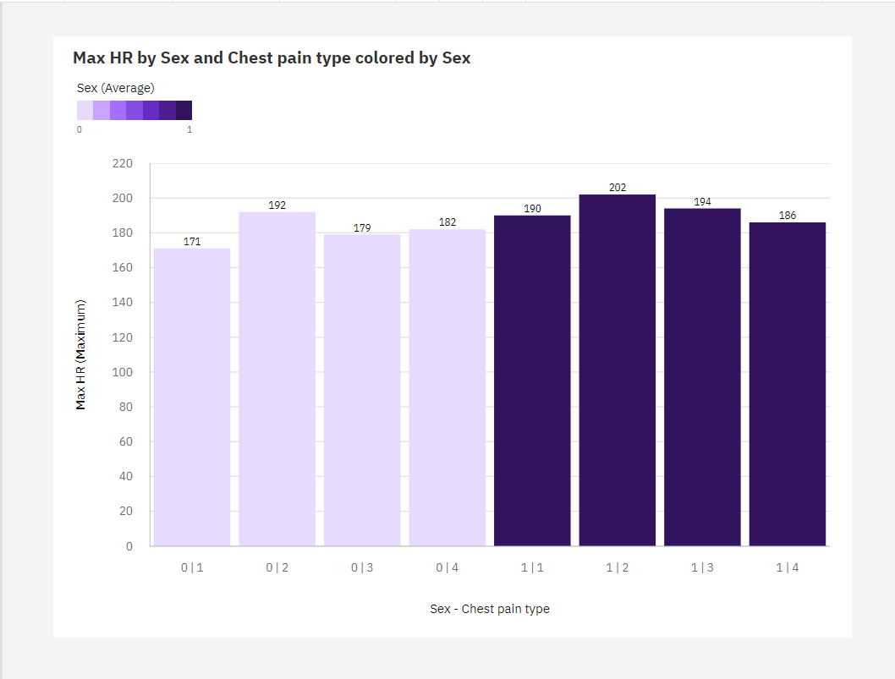

1. Over all sex - chest pain types, the average of BP is 2.174.
2. The average values of **BP** range from 0, occurring when **Sex - Chest pain type** is 0|1, to 3, when **Sex - Chest pain type** is 0|1.
3. The most common value of **Sex - Chest pain type** is 0|2, occurring 183 times, which is 67.8 % of the total.